Dr. Ameeta Salaria 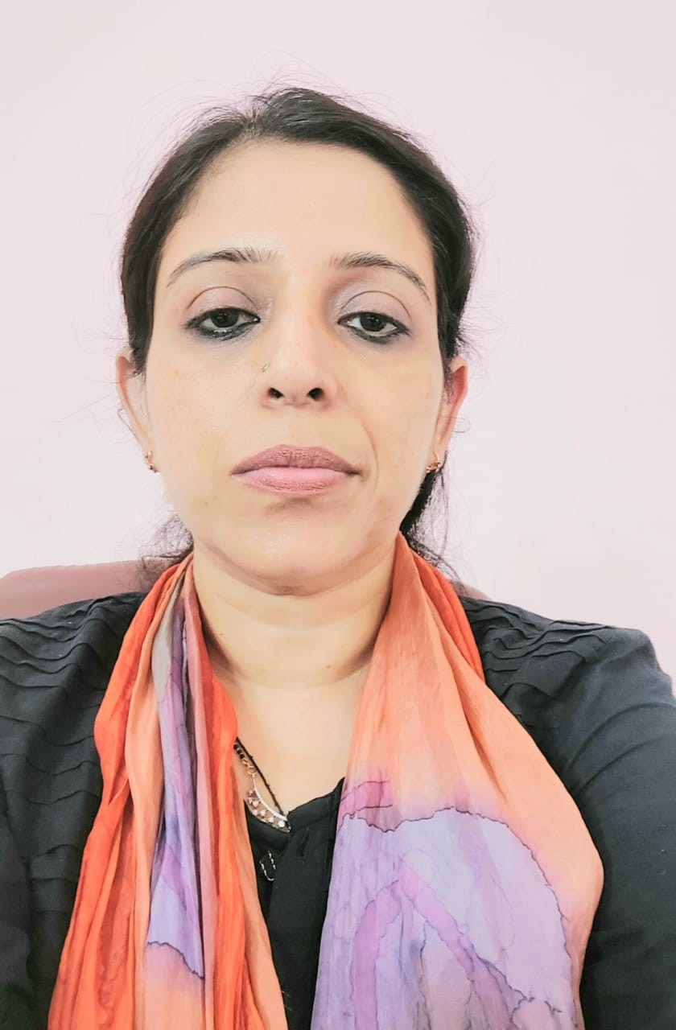

Academic PROFILE:

    - B.Sc. Food Science
    - M.Sc. Food Science and Technology
    - PhD Dairy Technology

Teaching Experience: Worked as a lecturer in PSPS GCW Gandhi Nagar for a period of eight years as UG and PG faculty in Department of Food Science and Technology
i.e., in 2011,2012 and 2013 held at Govt, College for women Gandhi Nagar Jammu.

Investigational Project in masters and pHd:

MS.C. “Utilization and evaluation of whey in whey-based fruit juice beverages”
Ph.D: “Preparation of probiotic adjunct for infant food formulation.”

Research article and Abstracts:

- Spray-dried Probiotic adjunct with in vitro acid and bile salt tolerance. Indian J Dairy Sci 76(1): 38-43(2023)
- Physico-chemical and shelf-life study of Low Calorie Ready to reconstitute (RTR) Health Beverage containing Bioactive Constituents. The pharma innovation journal SP-11(6): 2763-2767. (2022
- Evaluation of Quality attributes of litchi (Lithi Chinensis Sonn.) flavoured Honey Yoghurt during Storage. Biological Forum- An International Journal. 14(4): 253-257. (2022)
- Effect of Blending Apple Juice on the Sensorial Characteristics of Whey Beverage during
- Biological Forum- An International Journal. 14(4): 298-301. (2022)
- Prebiotics in the microencapsulating matrix enhance the viability of probiotic Lactobacillus acidophilus LA1. International Journal of Fermented Foods: v.2 n.1 p.33-45.(2013)
- Research abstract “Effect of co-encapsulation of probiotic Lactobacillus acidophilus LA 1 with prebiotics on their survival under in vitro acidic and bile salt conditions” published in a compendium of the international conference on Fermented foods SASNET in Aanand

Book Chapter:
Agrarian conditions and post-harvest practices of faba bean in Faba bean: Chemistry, properties and functionality. 2022, Springer,pp 17-26.
Clary sage essential oil in Essential Oils,2022, Springer, 2023.DOI: 10.1016/b978-0-323-91740-7.00001-3

Training Compendium:
Safety Aspects of Food additives Satish M.H. and Ameeta Salaria published in compendium of winter school
A strategy to improve the stability of probiotic organisms: Latha Sabikhi, Ameeta Salaria Microencapsulation in course compendium of National training programme on Basic and applied approaches in Designing of Dairy Based Nutraceuticals and Functional Foods July 18-27(The core faculty member in this training include Prof Hannu. J. Korhonen Head biomolecule research MTT Agrifood research Finland).
“Microencapsulation of microbial cultures – protocol”: Latha Sabikhi, Ameeta Salaria Microencapsulation in course compendium of National training programme on Basic and applied approaches in Designing of Dairy Based Nutraceuticals and Functional Foods July 18-27.

“Microencapsulation a valuable strategy for probiotic starters” published at national seminar on “Recent advances in The Development of Fermented foods” at BHU (Banaras Hindu University) April 8-9

Inplant Training:

Four months in plant training at ISO:9001 & HACCP(IS:15000) certified Model Dairy Plant an autonomous unit under ICAR, Karnal.
Two months in plant training at Experimental Dairy of NDRI, Karnal. Worked in Market milk section, Cheese and butter section, Condensing and Drying section and Quality control Laboratory of the institute’s dairy
Six months in plant training in JKMPCL (Jammu and Kashmir milk Producers Cooperative Limited, Satwari, Jammu.
One month food preservation training at Food Preservation Centre, Chand Nagar, Jammu.
15 days training at IFCA, Gangyal

WorkshopS and conferences:

Attended international Conference, on ‘Traditional dairy products’ at NDRI, Karnal.
Participated in two days National Seminar on “Recent Advances in The Development of Fermented foods” at BHU (Banaras Hindu University)
Attended And presented poster at conference of Indian Dairy Association, At New Delhi
Oral presentation on Nanotechnology in JK SCIENCE CONGRESS at Jammu University
Six-day workshop on, ‘Food Manufacture and Quality Control’ organized by GCW Gandhi Nagar.
Six days workshop on’ Towards better understanding of Food industry’ organized by GCW, Gandhinagar, under the auspices of UGC
One-month EDP (entrepreneur development course) by SISI, Ministry of Small-Scale Industries, Jammu
Five days workshop on Food Industry in J&K organized by GCW Gandhi Nagar, sponsored by ministry of Food Processing, Govt. of India

EXTRACURRICULAR ACTIVITIES

Coordinator member, in ‘DOFA’ (Department of Fine Arts) with NDRI ‘Student Union’ for two consecutive years, 2007 and 2008.
Worked, as a team member, in Dairy Mela at’ dairy technology’ stall for which first prize was given for best stall.
Helped in organization and management of National workshop on ‘Institute Industry Participatory research’, by DTSI,NDRI.
Acted, as a judge on, ‘World milk Day’ for painting Competition.
Imparted practical demonstration of microencapsulation to assistant professors/scientists of ICAR institutes, other universities in various trainings and short courses at NDRI.
Participated as a member in “Auditorium decoration committee” and “Refreshment and Catering committee” in “Annual Declamation Contest for Silver Rolling Trophy’ for three consecutive years

